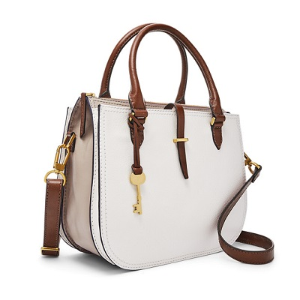

RYDER SATCHEL

PRODUCT DETAILS

**Silhouette: Satchel**

**Tech Compatibility: iPhone® 6, iPhone® 7, iPhone® 8**

**Exterior Material: Leather**

**Interior Details: 1 Zipper Pocket, 2 Slide Pockets**

**Measurements: 12"L x 6"W x 10"H**

**Handles/Straps: 1 Adjustable & Detachable Shoulder Strap, 2 Handles**